Comp 3710

Assignment 3

Zikun Xu

Guide for user:

I build my app on Android 10.0. So, user need Android 10.0 or newer device to run this App.

Step 1

Open my app

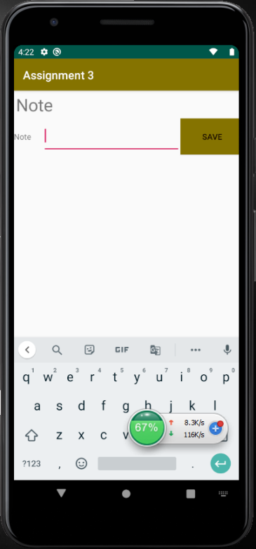

Step 2

Type the note you want and click the save bottom

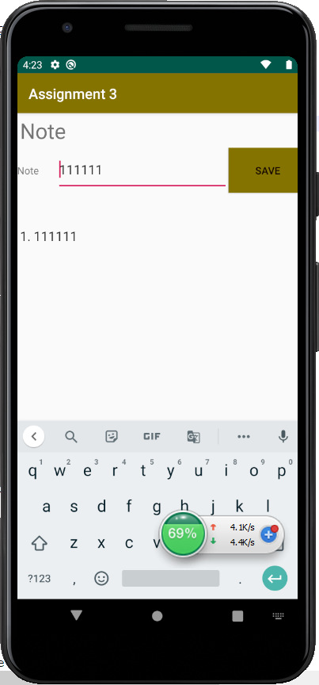

Step 3

If you want to type more note, the note list is under the line you type in.

